Course Work Submission

|  |  |  |  |
| --- | --- | --- | --- |
| Name | Ren | Yuxuan |  |
| ID Number | 1823678 | |  |
| Degree programme | Information and Computer Science | |  |
| Module Title | Computer Graphic | |  |
| Module Code | CPT205 | |  |
| Assignment Title | 2D Modelling Project | |  |
| Submission Deadline | Monday, 9 November 2020 | |  |
| Lecturer Responsible | Yong Yue | |  |

I certify that:

* I have read and understood the University’s definitions of COLLUSION and PLAGIARISM (available in the Student Handbook of Xi’an Jiaotong-Liverpool University).

With reference to these definitions, I certify that:

* I have not colluded with any other student in the preparation and production of this work;
* this document has been written solely by me and in my own words except where I have clearly indicated and acknowledged that I have quoted or used figures from published or unpublished sources (including the web);
* where appropriate, I have provided an honest statement of the contributions made to my work by other people including technical and other support staff.

I understand that unauthorized collusion and the incorporation of material from other works without acknowledgement (plagiarism) are serious disciplinary offences.

Signature ……Yuxuan.Ren……… Date ……2020.11.4*…*………

|  |  |  |  |
| --- | --- | --- | --- |
| For  Academic  Office use: | Date Received | Days Late | Penalty |
|  |  |  |

In general, my birthday card is not a fixed scene with some dynamic effects. It is a “birthday world”. You can see the greeting messages only after you enter this world. I designed my card this way because I think it’s a virtual card, so I don’t need to be too realistic.

The main idea is: A magician on a stage opens the door to the birthday world for you. And when you enter this world, you will see the morning and night of this world. Different scenes at different times.

The keyboard and mouse I use:

|  |  |
| --- | --- |
| Q or q | Exit |
| S or s | Make the heart move |
| Z or z | Make the sun smile to you |
| X or x | Fill up the sun |
| D or d | Change the scene to night |
| B or b | Make the smile face blow the candles |
| Left button | Make the heart bigger |

Brief instruction section:

1. You will see a magician with a big door (Figure 1). It is like a magic show on a stage.

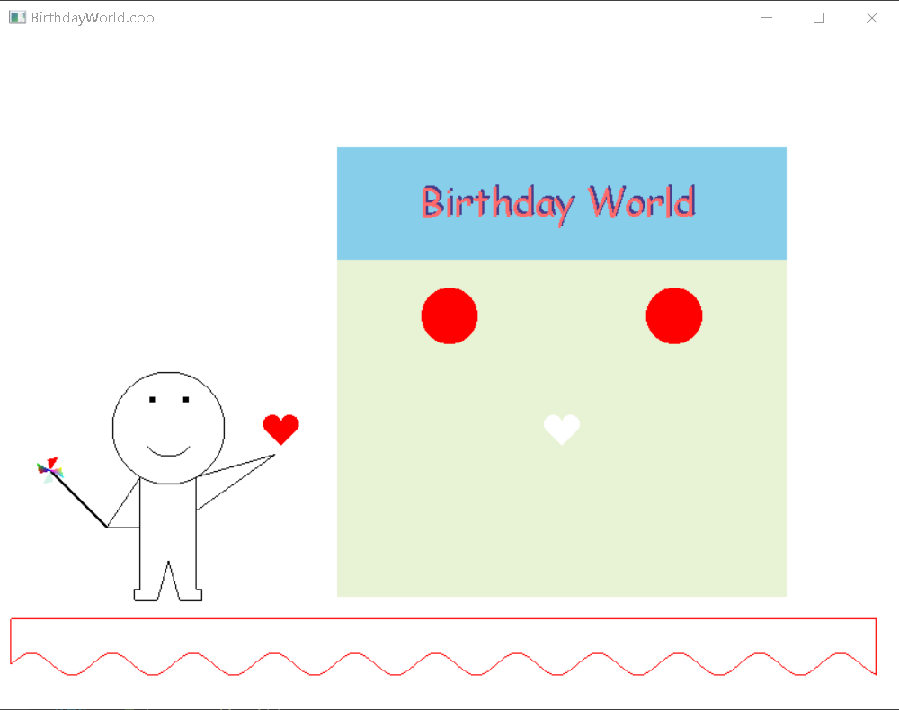

Figure 1

1. When you press ‘S’ or ‘s’, the red heart will move to the position of the white one. Then some effects occur (Figure 2).

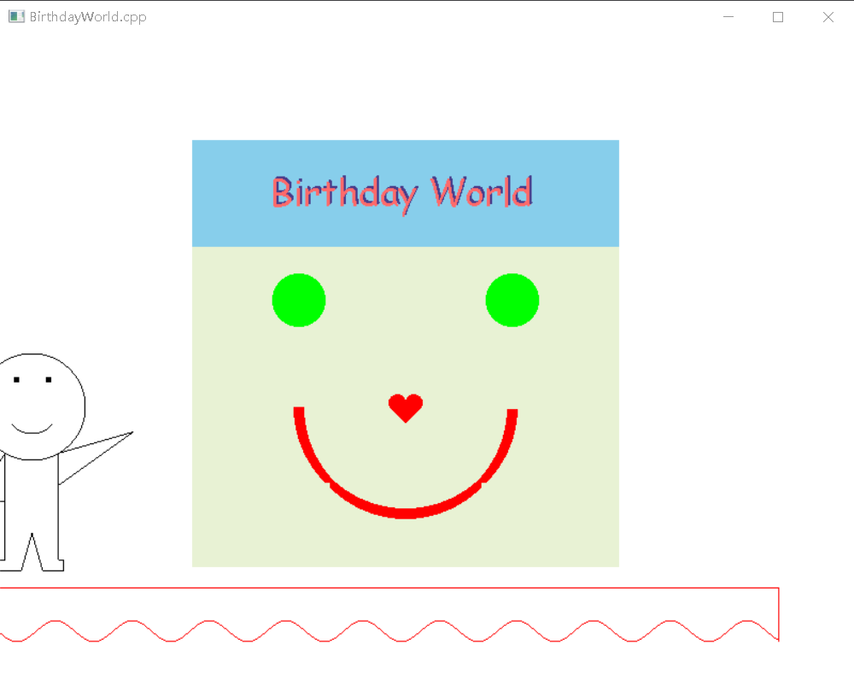

Figure 2

1. At this stage, you need to click the left button to make the heart bigger and bigger (Figure 3 and 4). After clicking for 6 times, the heart is reduced to a point and the second scene occurs (Figure 5).

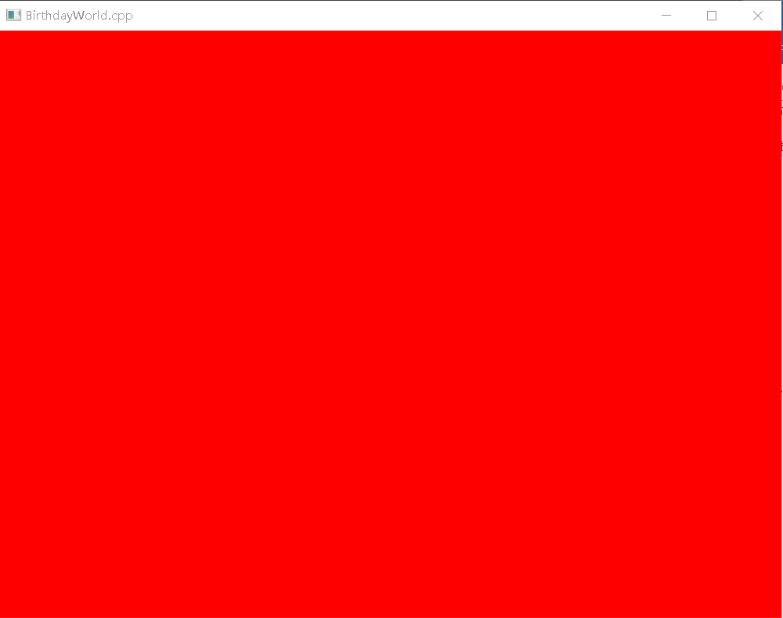

Figure 4

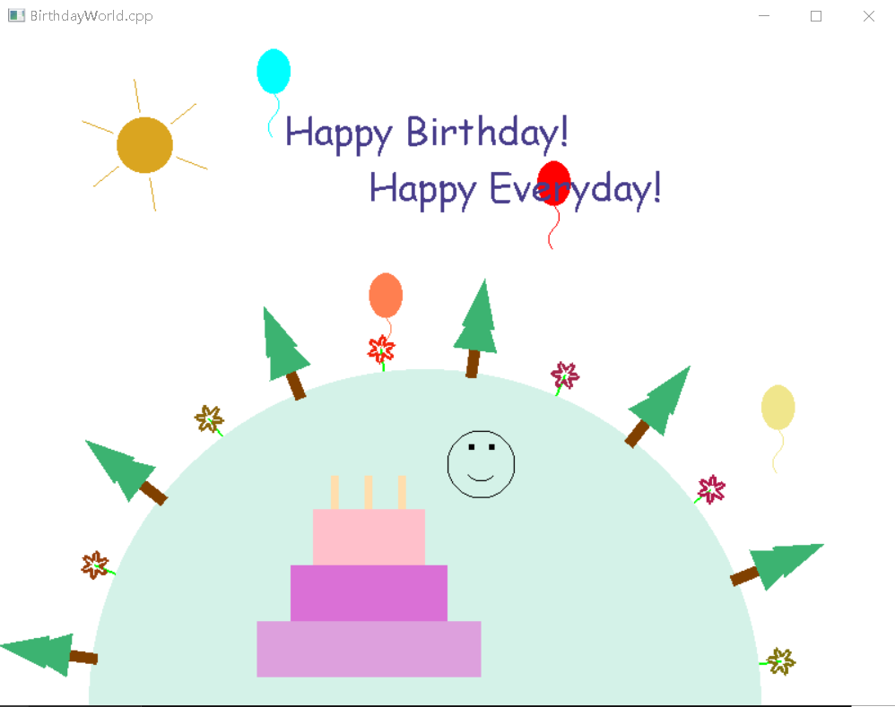

Figure 5

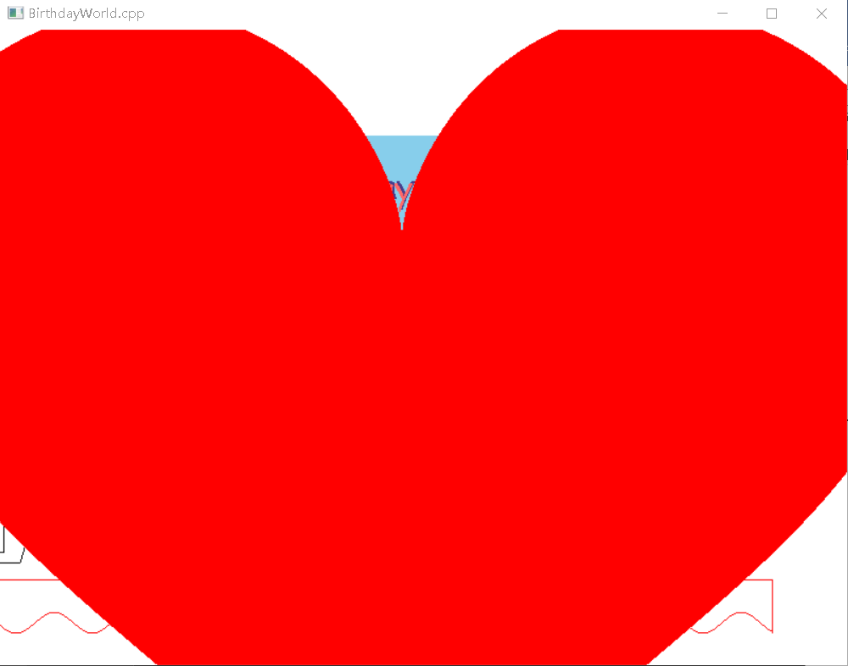

Figure 3

1. Now, you can press ‘Z’ or ‘z’ to make the sun smile to you (Figure 6). And press ‘X’ to turn the sun back to what it was.
2. Then, you can press ‘D’ or ‘d’ to switch the time to evening (Figure 7). The moon comes out in the evening. The candles on the cake light up.

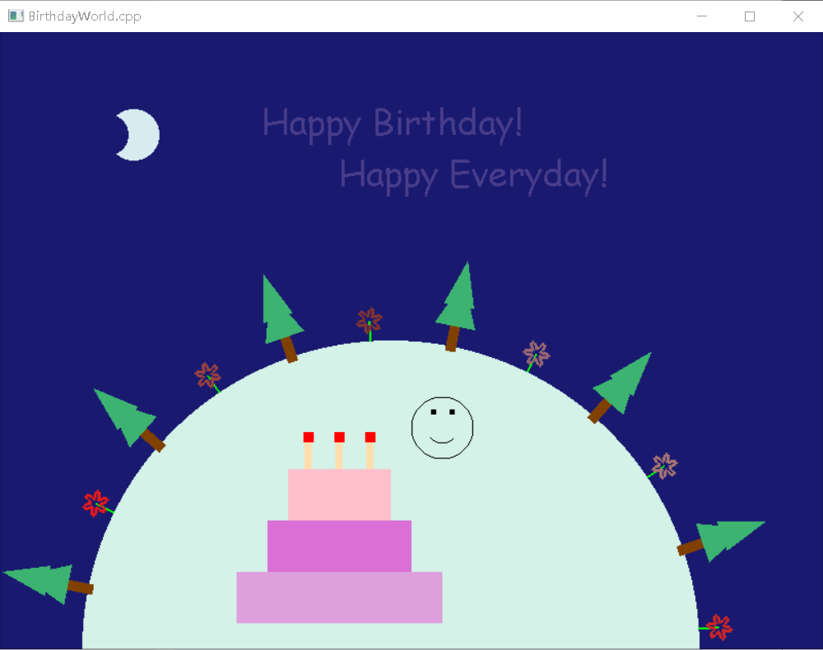

Figure 7

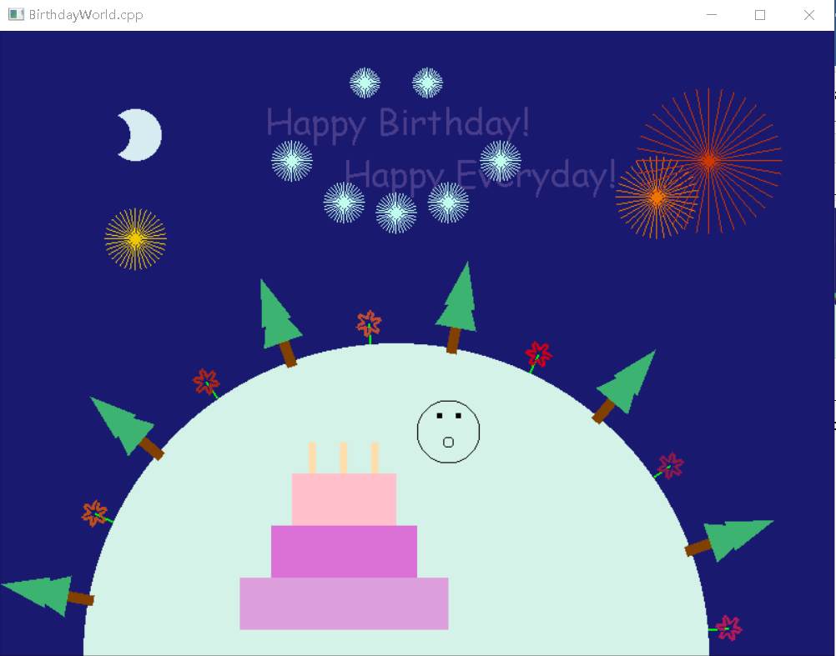

Figure 8

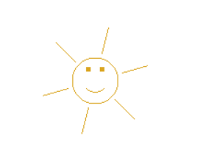

Figure 6

1. You can press ‘B’ or ‘b’ to let the smile ‘boy’ blow the candles for you. Several fireworks go off and give you another smile face. Remember to pay attention to the change of the mouth of the smile ‘boy’ (Figure 8).

The components and graphic techniques of my card:

My window is about 800*600. I use glViewport to make my card immune window change. And since I have two scenes. I draw the first scene from 0 to 1000 (x-axis) and the second scene from 1100 to 1900 (x-axis). When I need to change to the second scene, I just do a translation about -1000 along the x-axis (The camera movement is about 100).

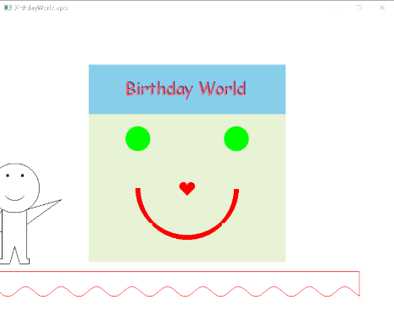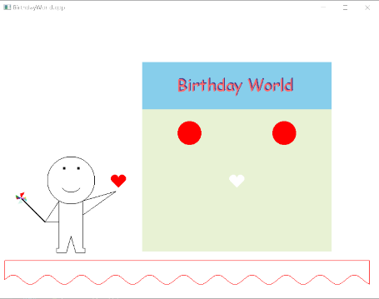On the first scene, the little boy is a magician, I draw him using GL_LINE_STRIP. His windmill is just a combination of four triangles (Using GL_TRIANGLES) with different colors (Two of them are multi-colored triangles). With the help of glTranslatef and glRotatef, I’m able to make it spin. The heart is a polygon using a parametric function as its vertexes which I found on the internet. At first, I want to use Cartesian heart-shaped curve, but it doesn’t look so beautiful, so I choose this one, a variation of the Cartesian heart-shaped curve. On the right side is a door (you can treat it as an entrance to the birthday world) with a “Birthday World” on it. There is a small trick. I write the words twice with two different colors and put them to similar positions, then the words seem more three-dimensional. The components are also very simple (rectangles, circles and a heart). At the bottom, there are three lines and a sine curve. It is a stage. I want to make the whole scene look like a show on a stage. Maybe it is too abstract, but I think that is enough.

With the movement of the heart, there are some effects. The change of the circles in color and the appearance of the smile is controlled by the translation parameter of the heart with an if condition. Every time the parameter increases by 0.5, when the heart reaches the target position, the camera moves. To achieve this, I change the parameter in gluLookAt. It is a pan.

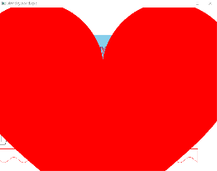I use glScalef to make the heart become bigger and bigger. The aim of this design is to switch to the second scene more normally.

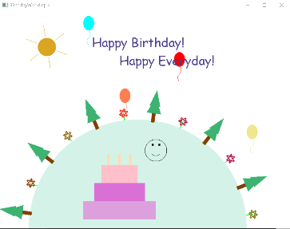Then with the heart becomes smaller and smaller (adjust the parameter of glScalef), the second scene appears. The texture style is still the same as the one in the first scene.

The sun is just a polygon and some lines with transformations. I use two polygon modes here. The normal one is a filled sun. If you press ‘z’ or ‘Z’, it will become just a figure of the sun (a circle) with a smile face in it. I do this by using a Boolean parameter. If the parameter is true, the sun will be drawn clockwise. Or it will be drawn counterclockwise. Since the smile and the sun have the same color, the smile disappears if the sun is filled. The earth is in the middle. There are some tricks when drawing trees and flowers. Since drawing every tree individually is a waste of time, I just draw one tree at the origin point. Then using a for loop and some transformations. The circle of the earth gives me several points which I can use to ‘plant’ these trees and flowers. Just remember to give different rotation angles to different trees and flowers. For the color of the flowers, I use random numbers. So that every time I make a screenshot, I will get different colors of flowers. I use the similar idea to draw balloons. But as long as the balloon disappears from the screen, I will shift the generate location a little bit to the right (I also make sure that the balloons are in the viewport by using modular operation). There is also a cake and a smile face. Smile face is my ‘old friend’, I use it several times. The cake is just a combination of many polygons. Three bold lines are the candles. They are lit only at night.

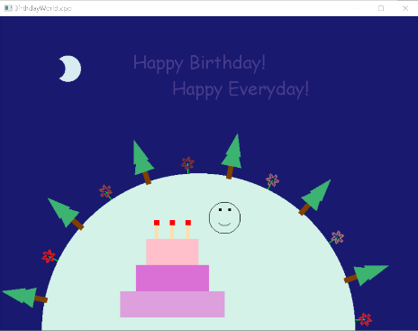After pressing the keyboard, the scene will change to the night. The moon replaces the sun. The drawing of the moon is just two circles. Because one circle’s color is as same as the background color, it cannot be seen. The candles are also set alight now. Then it’s time to blow the candles!

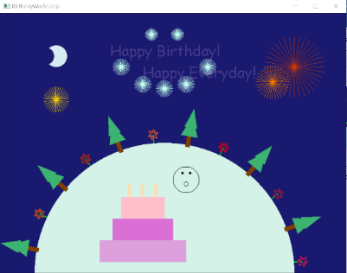This little boy makes his mouse like an ‘O’ and blows the candles (An if condition, two different paintings using GL_LINE_STRIP). After it, many fireworks rise to the sky. The fireworks are just several lines with the same starting points. In the middle, my idea is to have these fireworks paint a smiley face in the air. But this smile is a little bit abstract.